**Final Year Project Report**

**Project Name**



**Project Advisor:**

**Submitted By:**

**Session**

**University of Management and Technology**

**C-II Johar Town Lahore Pakistan**

**Acknowledgment**

**Abstract**

# Contents

*New paragraphs formatted as Heading 1, Heading 2, and Heading 3 will be added to the table automatically. To update this table of contents in Microsoft Word, put the cursor anywhere in the table and press F9. If you want the table to be easy to maintain, do not change it manually.*

Contents 1

Definitions and Acronyms 3

List of Figures 4

List of Tables 5

1. Introduction 6

1.1 Motivations 6

1.2 Project Overview 6

1.3 Problem Statement 6

1.4 Objectives 6

2. Domain Analysis 7

2.1 Customer 7

2.2 Stakeholders 7

2.3 Affected Groups with social or economic impact 7

2.4 Dependencies/ External Systems 7

2.5 Reference Documents 7

2.5.1 Related Projects 7

2.5.2 Feature Comparison 8

3. Requirements analysis 9

3.1 Requirements 9

3.2 List of Actors 10

3.3 List of use cases 10

3.4 System use case diagram 10

3.5 Extended use cases 10

3.6 User interfaces (mock screens) 12

4. Data flow diagram (optional) 13

4.1 Data Flow Diagram Level 0 13

4.2 Data Flow Diagram Level 1 13

4.3 Data Flow Diagram Level 2 13

5. System Design 15

5.1 System Architecture Diagram 15

5.2 Class Diagram 16

5.3 Collaboration Diagrams 17

5.4 Other UMLs 18

5.5 ERD 18

5.6 Data Dictionary 18

6. Implementation details 19

6.1 Development Setup 19

6.2 Deployment setup 19

6.3 Algorithms 19

6.4 Constraints 19

6.4.1 Assumptions 19

6.4.2 System constraints 19

6.4.3 Restrictions 19

6.4.4 Limitations 19

7. Testing 20

7.1 Extended Test Cases 20

7.2 Decision Table 20

7.2.1 Code snippet 20

7.2.2 Decision coverage table 20

7.3 Traceability Matrix 21

7.3.1 RID vs UCID (requirements vs use cases) 21

7.3.2 Prototypes (RID vs PID) 22

7.3.3 Test Cases (RID vs TID) 22

7.3.4 Coverage (UCID vs TID) 22

8. Results/Output/Statistics 23

8.1 %completion 23

8.2 %accuracy 23

8.3 %correctness 23

9. Conclusion 24

10. Future work 25

11. Bibliography 26

11.1 Books 26

11.2 Journals 26

11.3 Articles 26

11.4 Research papers 26

11.5 Other References 26

12. Appendix 27

12.1 Glossary of terms 27

12.2 Pre-requisites 27

## Definitions and Acronyms

*Provide definitions or references to all the definitions of the special terms and acronyms used within this document*

e.g

|  |  |
| --- | --- |
| **Acronym** | **Definition** |
| UMT | University of Management and Technology |
| POS | Point of Sale |

Table 1: table of acronyms and definitions

## List of Figures

New figures that are given captions will be added to the table automatically.

* **Insert caption:**
  1. select picture
  2. right click
  3. select “insert caption”
  4. under “options”, choose label as “figure”
  5. Under “caption”, an automatic insertion of “figure no” will appear. Give your figure an appropriate caption
* **Update list of figures:**To update this list in Microsoft Word, put the cursor anywhere in the table and press F9.
* **Note:**  If you want the table to be easy to maintain, do not change it manually.

Figure 1: sample use case diagram with explanation 10

Figure 2: System Architecture 15

## List of Tables

New Tables that are given captions will be added to the table automatically.

* **Insert caption:**
  1. select picture
  2. right click
  3. select “insert caption”
  4. under “options”, choose label as “table”
  5. Under “caption”, an automatic insertion of “table no” will appear. Give your table an appropriate caption
* **Update table:** To update this table of contents in Microsoft Word, put the cursor anywhere in the table and press F9.
* **Note:**  If you want the table to be easy to maintain, do not change it manually.

Table 1: table of acronyms and definitions 3

Table 2: list of stakeholders 7

# Introduction

*This section should describe the project and the software product being to be built. No text is necessary between the heading above and the heading below unless otherwise desired.*

## Motivations

This section deals with the motivation behind choosing this project.

## Project Overview

Give a short summary of the project objective and the system to be developed.

Following are the sample artifacts for this section:

* Problems or Overview Statement
* Customer
* Goals
* System functions
* System attributes

## Problem Statement

This section should describe the need for this projectand the problem this project is addressing.

The problem statement should be brief, comprising of not more than 150 words

## Objectives

What objectives (outcomes) do you expect to achieve on the completion of this project. e.g.

* Give precise allocation of class rooms
* Generate an image analysis system for suspect identification
* Analysis of data for fraud detection
* …

# Domain Analysis

## Customer

A brief description of the client with whom you are working (or the potential customers). The organization, its products/services etc.**You will fill this section only if you have a client (contracted) .**

## Stakeholders

List of all stakeholders along with their roles in making of the system e.g

|  |  |
| --- | --- |
| **Stakeholder** | **Role in System** |
| Class coordinator | He is responsible for allocating classrooms for different department. In case of clash/missed classes, he is responsible for entering the details in the system. At the end of the week, he can request the system to generate appropriate reports on no. of clashes reported or missed classes. |

Table 2: list of stakeholders

## Affected Groups with social or economic impact

Those impacted by the deployment of the system. This can be a simple list as well as a bulleted one with short explanations.**Link them with your objectives**

e.g.

* Sales staff

There will be reduced paper work for them. Also they will be able to provide better customer care as system will help them respond to queries quickly.

This may include users as well as support groups

## Dependencies/ External Systems

Systems and/ or products, this project depends upon for its completion.

e.g.

* Cyber Cash

## Reference Documents

Provide references to all documents that have been consulted during the analysis phase.

### Related Projects

List of all the documents/ projects that you have looked up as reference material for this project along with their links/references. E.g

In order to develop UMTmanagementSystem, we looked up several similar systems. Their details are given below

1. FastManagementSystem(FMS)

Developed by XYZ. The partial documentation was obtained by the XYZ development team and the working of this management software was observed from abcFAST.com.pk

1. BeaconHouse Management System (BHMS)

Developed by ABC. the working of this management software was observed from abcbeaconhouse.com.pk. no relevant documentation was available.

1. “constructing and ideal academic system” (CIAS)

Research paper published by IEEE. The research paper is not available for free. It is only available to IEEE members

### Feature Comparison

|  |  |  |  |  |  |
| --- | --- | --- | --- | --- | --- |
| Sr No. | Comparison Feature | FMS | BHMS | CIAS | remarks |
| 1 | ABC | FMS covers the feature ABC completely as desired | BHMS does not support feature ABC | CIAS suggests that maximum efficiency can be achieved if ABC is implemented using algorithm abc. | Using the ABC feature from FMS and improving it with abc algorithm can provide maximum efficiency |

# Requirements analysis

## Requirements

*This section is can be skipped, if Requirement Specifications document has been developed for the project. Otherwise this section is mandatory.*

*This section may contain*

*End user, operator, support, or integration functions,*

*Performance requirements,*

*Design constraints,*

*Programming language, and*

*Interface requirements.*

*System functions are descriptions of what a system is supposed to do. They should be identified and listed in logical cohesive groups, with their category (priority) assigned. These system functions will be identified as a result of the requirement gathering process conducted with the client. However, in some cases, prior to the development of the Functional Specifications the requirements may already have been listed in a document: if this is so then a reference to the document may suffice.*

*To verify that some* ***X*** *is indeed a system function; it should make sense in the following sentence:*

*The system should do <****X****>*

*The table below gives an example of how system functions can be listed:*

*The Functions column gives a brief one-line description of the required functionality.*

*The Category column refers to the status of the functionality for the proposed system. The options for the Category are defined below.*

*The Attribute column defines the system characteristics. The Details and Constraints column specifies the conditions within which the attribute is applicable. Section 1.12 defines the default Attributes and the related Constraints. In case, the default conditions are to be over-ridden then the conditions can be defined in this table.*

*Function Categories*

|  |  |
| --- | --- |
| ***Functional Requirements*** | ***The services requested by the user*** |
| *Non-Functional Requirements* | *The supporting requirements for functional requirements. Theses include the* ***measureable*** *quality attribute.* |
| *Data Requirements* | *How your data will be stored* |
| *Constraints* | *by the client On your system* |
| *External interface requirements* | *How will your system connect to other software/components* |

|  |  |  |  |  |
| --- | --- | --- | --- | --- |
| *RID* | *description* | *Category* | *Attribute* | *Details & Boundary Constraints* |
| *R1.1* | *Record the underway sale – the items purchased* | *non-functional* | *System Response time* | *Price listing within 3 seconds*  *Availability agreement in less than 10 sec* |
| *R1.2* | *Reduce inventory quantities when a sale is committed* | *non-functional* | *Concurrent user load* |  |

## List of Actors

Define the system boundary and list all actors with the use cases.**all the actors must also be mentioned in your list of stakeholders**

For example:

Cashier; this person performs all the financial activities

Account Manager; this person supervises all financial activities

## List of use cases

List all the use cases, with a brief description (should not exceed two lines):

Buy Item; captures a sale and its payment

Log In; allow user to provide account information and access the restricted services

## System use case diagram

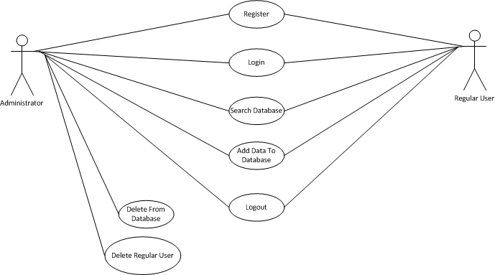

Figure 1: sample use case diagram with explanation

## Extended use cases

**UC1 _ Login**

|  |  |  |  |  |
| --- | --- | --- | --- | --- |
| **Use Case ID:** | UC-1 | | | |
| **Use Case Name:** | Login | | | |
| **Created By:** | Farooq Azam | | **Last Updated By:** | Farooq Azam |
| **Date Created:** | 9-1-2023 | | **Last Revision Date:** | 9-1-2023 |
| **Actors:** | | 1. Admin 2. Student or User | | |
| **Description:** | | Actor must have to login LMS. Before performing any action | | |
| **Trigger:** | | This use case is triggered by Login Button from Login Page | | |
| **Preconditions:** | | 1. Student or User must have to be registered on LMS.  2. Student or User must be on Login Page in LMS.  3. Student or User must remember his email and Password | | |
| **Post conditions:** | | Student or User will be login in LMS. | | |
| **Normal Flow:** | | 1. Type email address  2. Type password  3. Student or User , admin click on login butten. | | |
| **Alternative Flows:**  **[Alternative Flow 1 – Not in Network]** | | 1. Type email  2. Type password  3. Click login button  4. Error occur email and password not match  5. Use case will resume from step 1  6. User logged in successfully | | |
| **Exceptions:** | | 1. In use case number 3 .  2. Entered email not matched in database .  3. Entered password is not correct . | | |
| **Frequency of Use:** | | This use case has frequency of use less than 70 request per day | | |
| **Special Requirements:** | | 1. Internet  2. student or User must be on login page | | |
| **Assumptions:** | | Student or User must have basic knowledge of internet browsing and e- LMS | | |
| **Notes and Issues:** | | It doesn’t have any issue | | |

**UC2_Forget Password**

|  |  |  |  |  |
| --- | --- | --- | --- | --- |
| **Use Case ID:** | UC-2 | | | |
| **Use Case Name:** | Forget Password | | | |
| **Created By:** | Farooq Azam | | **Last Updated By:** | Farooq Azam |
| **Date Created:** | 9-1-2023 | | **Last Revision Date:** | 9-1-2023 |
| **Actors:** | | 1. Admin 2. Student or User | | |
| **Description:** | | This use case is for recovering the password of user account in e-LMS | | |
| **Trigger:** | | This use case is triggered by Forget Password Button from Login Page | | |
| **Preconditions:** | | 1. Student or User must have to be registered e-LMS.  2. Student or User must be remember his email address | | |
| **Post conditions:** | | Email will be sent to the given email address with password recovery link. | | |
| **Normal Flow:** | | 1. Student or User click on the forget password  2. Student or User will enter email address  3. System or User will validate email address from database  4. System or User will send recovery email | | |
| **Alternative Flows:**  **[Alternative Flow 1 – Not in Network]** | | 1.Click on the forget password  2.Student will enter email address  3.Error occurs email not match  4.User will enter email address  5.System will validate email address from database  6.System will send recovery email | | |
| **Exceptions:** | | 1. In use case number 3  2. Entered Email not matched in database | | |
| **Frequency of Use:** | | This use case has frequency of use less than 20 request per day | | |
| **Special Requirements:** | | 1. Internet 2. Student must be on registered on | | |
| **Assumptions:** | | Student or User must have basic knowledge of internet and e-LMS. | | |
| **Notes and Issues:** | | It doesn’t have any issue | | |

**UC4_Register Courses**

|  |  |  |  |  |
| --- | --- | --- | --- | --- |
| **Use Case ID:** | UC-3 | | | |
| **Use Case Name:** | Register Courses | | | |
| **Created By:** | Farooq Azam | | **Last Updated By:** | Farooq Azam |
| **Date Created:** | 9-1-2023 | | **Last Revision Date:** | 9-1-2023 |
| **Actors:** | | Student or User | | |
| **Description:** | | This extended use case is for register Courses on e -LMS | | |
| **Trigger:** | | This use case is triggered by Sign up Button from Register Page. | | |
| **Preconditions:** | | Student or user must have to be have valid email address. | | |
| **Post conditions:** | | Student or user will get registered on e-LMS and an email will be sent on its email address for email verification. | | |
| **Normal Flow:** | | Student or user will enter the following details.  1.First Name  2.Last Name  3.Email address  4.D.O.B  5.Location  6.Phone Number  7.Education  8.Enter Password  9.Confirm Password  10.Captcha  11.Click on signup button | | |
| **Alternative Flows:**  **[Alternative Flow 1 – Not in Network]** | | Student or User must be type following details  First Name, Last Name, Email address, Education, Date of Birth, Phone Number, Location, Captcha, click on signup button, Email address must be correct format (example@gmail.com), Age must be 9 or above, , User must click on signup | | |
| **Exceptions:** | | In use case no 1 -User or Student didn’t enter first name -Form interface shows error and says first name can’t be left empty -use case resumes at step1 | | |
| **Frequency of Use:** | | This use case has frequency of use less than 20 request per day | | |
| **Special Requirements:** | | Internet | | |
| **Assumptions:** | | Student or User must must have basic Knowledge of Internet And e-LMS | | |
| **Notes and Issues:** | | There is no issue. | | |

**UC4_Accept Courses**

|  |  |  |  |  |
| --- | --- | --- | --- | --- |
| **Use Case ID:** | UC-4 | | | |
| **Use Case Name:** | Accept Courses | | | |
| **Created By:** | Farooq Azam | | **Last Updated By:** | Farooq Azam |
| **Date Created:** | 9-1-2023 | | **Last Revision Date:** | 9-1-2023 |
| **Actors:** | | Admin | | |
| **Description:** | | This extended use case is for accept Courses on e -LMS | | |
| **Trigger:** | | This use case is triggered by pending courses link. | | |
| **Preconditions:** | | Student or user must have to be have valid email address.  Student or user must be login in e-LMS. | | |
| **Post conditions:** | | Student or user request will be either accepted or rejected. | | |
| **Normal Flow:** | | 1. View List of pending Courses  2. Select Course  3. Click Accept or Reject | | |
| **Alternative Flows:**  **[Alternative Flow 1 – Not in Network]** | | 1. View List of pending Courses  2. Select Course  3. Click Accept or Reject | | |
| **Included:** | | Login | | |
| **Frequency of Use:** | | This use case has frequency of use less than 20 request per day | | |
| **Special Requirements:** | | Internet | | |
| **Assumptions:** | | Student or User must must have basic Knowledge of Internet And e-LMS | | |
| **Notes and Issues:** | | There is no issue. | | |

**UC5_Edit Courses**

|  |  |  |  |  |
| --- | --- | --- | --- | --- |
| **Use Case ID:** | UC-5 | | | |
| **Use Case Name:** | Edit Courses | | | |
| **Created By:** | Farooq Azam | | **Last Updated By:** | Farooq Azam |
| **Date Created:** | 9-1-2023 | | **Last Revision Date:** | 9-1-2023 |
| **Actors:** | | Admin | | |
| **Description:** | | This extended use case is for edit Courses on e -LMS | | |
| **Trigger:** | | This use case is triggered by pending edit courses Button. | | |
| **Preconditions:** | | Student or user must have to be have valid email address.  Student or user must be login in e-LMS. | | |
| **Post conditions:** | | Course request must be Edit. | | |
| **Normal Flow:** | | 1. View List of pending Courses  2. Select Course  3. Click to Remove course. | | |
| **Alternative Flows:**  **[Alternative Flow 1 – Not in Network]** | | 1. View List of pending Courses  2. Select Course  3. Click to Edit course. | | |
| **Included:** | | Login | | |
| **Frequency of Use:** | | This use case has frequency of use less than 20 request per day | | |
| **Special Requirements:** | | Internet | | |
| **Assumptions:** | | Student or User must must have basic Knowledge of Internet And e-LMS | | |
| **Notes and Issues:** | | There is no issue. | | |

**UC6_Remove Courses**

|  |  |  |  |  |
| --- | --- | --- | --- | --- |
| **Use Case ID:** | UC-6 | | | |
| **Use Case Name:** | Remove Courses | | | |
| **Created By:** | Farooq Azam | | **Last Updated By:** | Farooq Azam |
| **Date Created:** | 9-1-2023 | | **Last Revision Date:** | 9-1-2023 |
| **Actors:** | | Admin | | |
| **Description:** | | This extended use case is for remove Courses on e -LMS | | |
| **Trigger:** | | This use case is triggered by pending courses link. | | |
| **Preconditions:** | | Student or user must have to be have valid email address.  Student or user must be login in e-LMS. | | |
| **Post conditions:** | | Course request must be removed. | | |
| **Normal Flow:** | | 1. View List of pending Courses  2. Select Course  3. Click to Remove course. | | |
| **Alternative Flows:**  **[Alternative Flow 1 – Not in Network]** | | 1. View List of pending Courses  2. Select Course  3. Click to Remove course | | |
| **Included:** | | Login | | |
| **Frequency of Use:** | | This use case has frequency of use less than 20 request per day | | |
| **Special Requirements:** | | Internet | | |
| **Assumptions:** | | Student or User must must have basic Knowledge of Internet And e-LMS | | |
| **Notes and Issues:** | | There is no issue. | | |

**UC7_Pending Detail of Courses**

|  |  |  |  |  |
| --- | --- | --- | --- | --- |
| **Use Case ID:** | UC-7 | | | |
| **Use Case Name:** | Pending details of Courses | | | |
| **Created By:** | Farooq Azam | | **Last Updated By:** | Farooq Azam |
| **Date Created:** | 9-1-2023 | | **Last Revision Date:** | 9-1-2023 |
| **Actors:** | | Admin | | |
| **Description:** | | This extended use case is for the pending details of Courses on e -LMS | | |
| **Trigger:** | | This use case is triggered by pending courses link. | | |
| **Preconditions:** | | Student or user must have to be have valid email address.  Student or user must be login in e-LMS. | | |
| **Post conditions:** | | System will show the pending courses details. | | |
| **Normal Flow:** | | 1. View List of pending Courses  2. Select Course  3. Click to Remove course. | | |
| **Included:** | | Login | | |
| **Frequency of Use:** | | This use case has frequency of use less than 20 request per day | | |
| **Special Requirements:** | | Internet | | |
| **Assumptions:** | | Student or User must must have basic Knowledge of Internet And e-LMS | | |
| **Notes and Issues:** | | There is no issue. | | |

## User interfaces (mock screens)

Initial mockup screens (even hand drawn drafts) will be inserted here. Each screen will be given an appropriate prototype id.e.g.

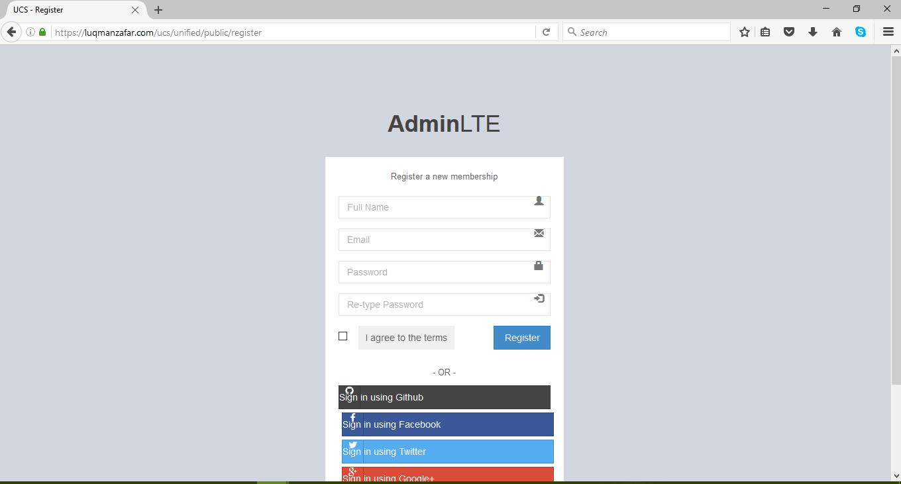

Prototype1: (P1) register a new member

# Data flow diagram

## Data Flow Diagram Level 0

Identifies sources and sinks only e.g

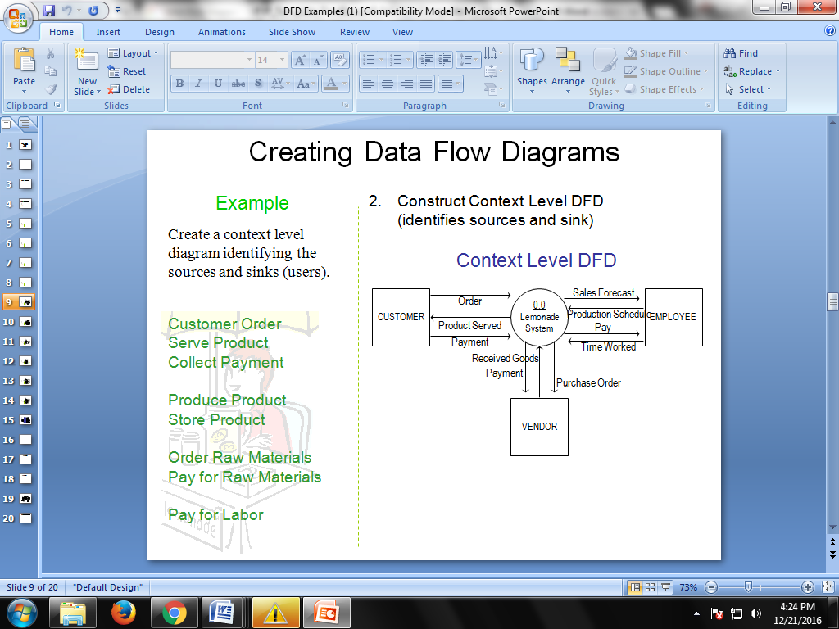

## Data Flow Diagram Level 1

Identifies actual data flows and data storese.g

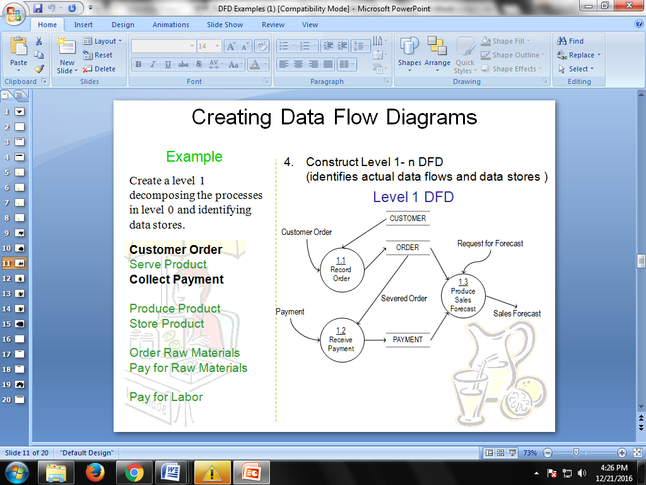

## Data Flow Diagram Level 2

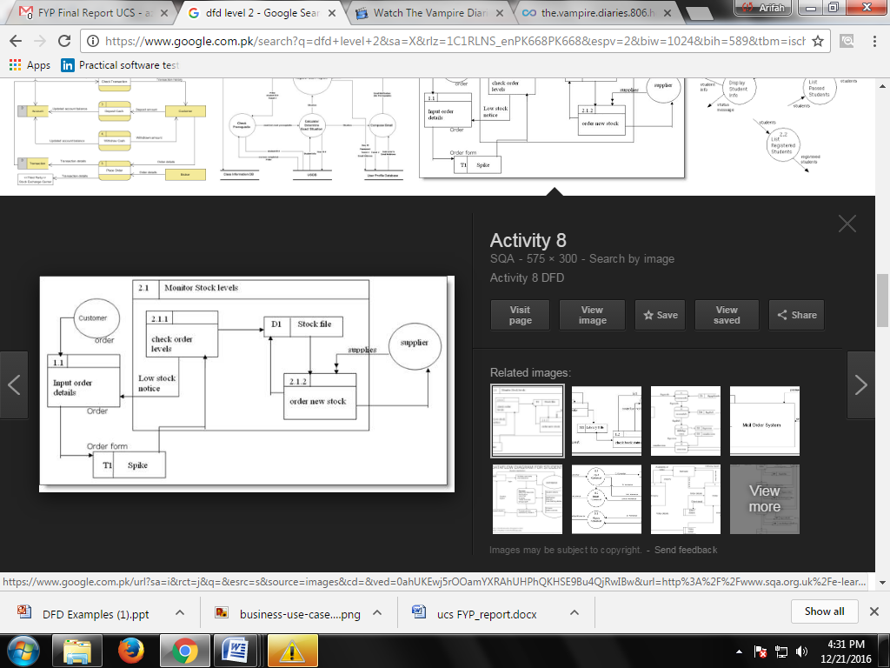

# System Design

Describe the system architecture, or simply provide the architecture diagram. For School system it may include web based front end, webserve , database etc. Don’t worry too much about it just give a simple diagram of a typical web based project.

## Class Diagram

## class-example-online-shopping-domain

## Sequence Diagrams

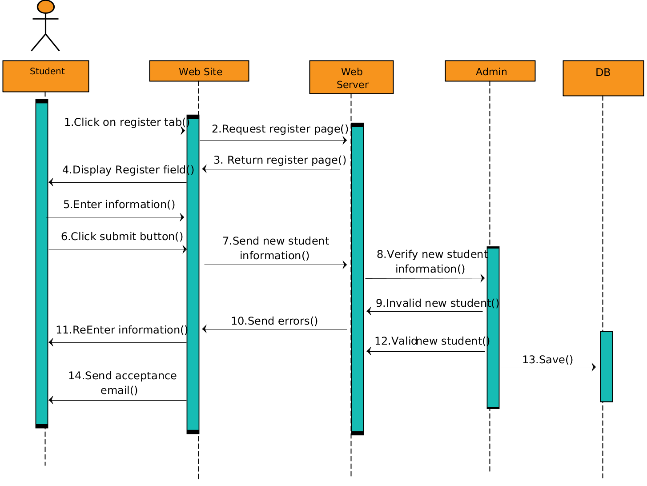

## Other UMLs

This is optional. You may include any other UML to support your system. Like Activity diagram.

## ERD

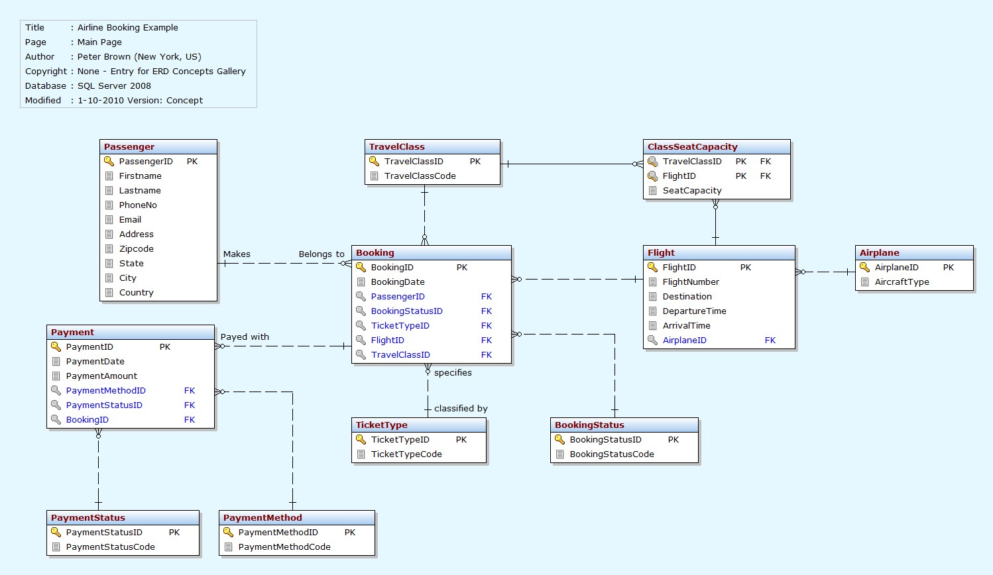

# Conclusion

# Future work

# Bibliography

Use IEEE or ACM format for citations

## Books

## Journals

## Articles

## Research papers

## Other References